Ghana

## Respect for rule of law (ROL) data

The data set shows the data on the respect of the rule of law for the country.

## # A tibble: 19 x 5  
## country iso3c date ruleOfLaw ruleOfLawCategory4   
## <chr> <chr> <dbl> <dbl> <chr>   
## 1 Ghana GHA 1996 -0.234 ROL moderately disrespected  
## 2 Ghana GHA 1998 -0.276 ROL moderately disrespected  
## 3 Ghana GHA 2000 0.155 ROL moderately respected   
## 4 Ghana GHA 2002 0.0424 ROL moderately respected   
## 5 Ghana GHA 2003 0.0689 ROL moderately respected   
## 6 Ghana GHA 2004 -0.119 ROL moderately disrespected  
## 7 Ghana GHA 2005 -0.116 ROL moderately disrespected  
## 8 Ghana GHA 2006 0.0545 ROL moderately respected   
## 9 Ghana GHA 2007 0.0357 ROL moderately respected   
## 10 Ghana GHA 2008 -0.0680 ROL moderately disrespected  
## 11 Ghana GHA 2009 -0.0421 ROL moderately disrespected  
## 12 Ghana GHA 2010 -0.0281 ROL moderately disrespected  
## 13 Ghana GHA 2011 -0.00488 ROL moderately disrespected  
## 14 Ghana GHA 2012 0.0105 ROL moderately respected   
## 15 Ghana GHA 2013 0.149 ROL moderately respected   
## 16 Ghana GHA 2014 0.0522 ROL moderately respected   
## 17 Ghana GHA 2015 0.142 ROL moderately respected   
## 18 Ghana GHA 2016 0.0472 ROL moderately respected   
## 19 Ghana GHA 2017 0.130 ROL moderately respected

## Respect for rule of law (ROL) trend

The plot shows the trend of the respect for the rule of law for the country.

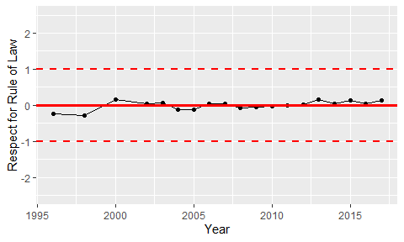

Trend of the Respect for the Rule of Law